Minor Project (BTCS607N) Weekly Progress Report (Week-7)
Project Title: Vaari - Crop Water Footprint Information App
Phase 3 — Object-Oriented Design
Goal: Define the overall system architecture of Vaari using component and deployment diagrams.
1. Introduction
- Week 7 focuses on system architecture.
- The purpose of this week is to show how the major modules of the Vaari system are organized and how they are deployed.
- The main deliverables are the component diagram and the deployment diagram.
2. Component Diagram
- The component diagram shows the high-level software modules of the Vaari application.
- It typically includes the Android UI, ViewModel layer, Repository layer, API service, and local database layer.
- This diagram helps explain how the software is divided into independent but connected parts.

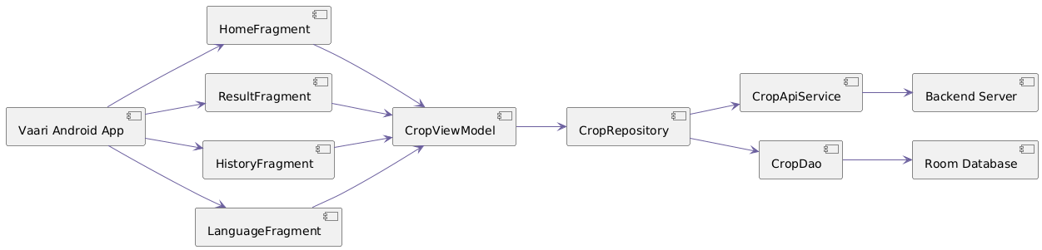
3. Deployment Diagram
- The deployment diagram shows where the software components run.
- For Vaari, the Android app runs on the user device, while the backend API runs on a server.
- Local storage such as Room database stays on the mobile device.
- This diagram helps map the software to hardware and runtime nodes.

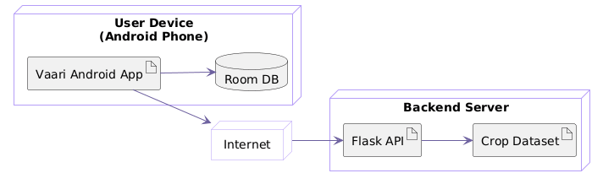
4. Architecture Overview
- Android UI communicates with ViewModel.
- ViewModel talks to Repository.
- Repository fetches data from API and saves history in local database.
- API service connects to the crop data backend.
- Room database stores search history on the device.
5. Scope of Week 7
- Week 7 is limited to architectural modeling.
- Code implementation is not the main focus at this stage.
- The architecture diagrams serve as a bridge between design and implementation.
6. Deliverables
- Component diagram.
- Deployment diagram.
- System architecture explanation.
7. Expected Outcome
- A clear view of the physical and logical structure of Vaari.
- An understanding of how modules communicate and where they are deployed.
- A complete architecture base for the implementation stage.
8. Team Roles
- Team members will work on drawing the architecture diagrams and documenting how the system is structured.

Mentor Signature __________________ Project Guide Signature ___________________

